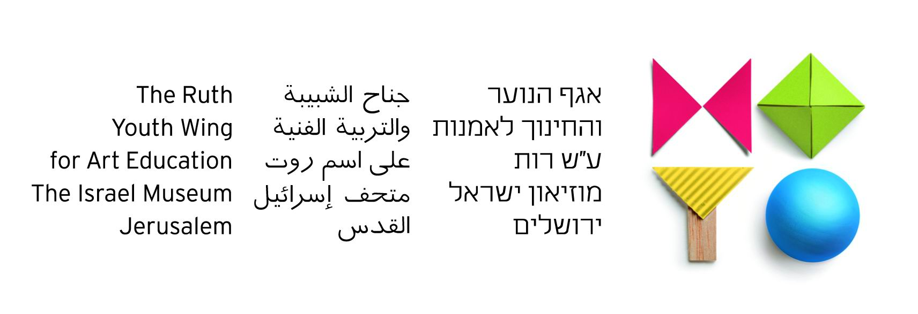

Bridging the Gap

The Jewish-Arab Art Program

2012/13 Report

Another fruitful year of the "Bridging the Gap" Art Program was successfully completed in June 2013. The program, initiated by the Ruth Youth Wing for Art Education in 1995, has been supported by the German Friends of the Israel Museum since 2010. Through the German Friends’ active and generous support, the program has become a great success, both in terms of artistic quality and in its ability to create opportunities for dialogue between Arab and Jewish youth in Israel.

Program for the Current Year
Introduction
During the 2012/13 school year, 76 sixth and eighth grade schoolchildren from throughout Jerusalem took part in the program, divided into two groups. At the outset, in September and October 2012, we met with school principals, teachers, parents, and administrators. Prior to September, we had formed a select group of students based on two major criteria:
a) A demonstrated curiosity and commitment to dialogue with the “Other”
b) An interest in and a motivation to create art.

Children from both communities have seldom experienced meeting the “other” in person. For the most part, the Museum encounters constitute the first opportunity for the participants to meet children of their age from the other community. Therefore, most arrive at the first encounter with the beliefs, perspectives, and attitudes about the “other” that they have received from their parents, exposure to at school, or acquired through the local media.

Program Curriculum
October-November 2012: “Getting to Know You” sessions include a primary meeting with all students and their parents during which the year program was presented; acquaintance with the Youth Wing staff running the program; a tour of the Youth Wing’s premises; and a guided tour in the Museum galleries.
December 2012: Initial art exercises for individuals and pairs, guided tours of Museum exhibitions, and conversations about art in order to foster dialogue and exchange between participants.
January-February 2013: Exploring in groups the concept of "Hobbies" through art workshops in the classroom and in the Museum galleries, thus finding cross-cultural commonalities and shared interests.
March 2013: A trip to Jaffa was organized, where the children enjoyed a bilingual play on the theme of friendship by the Arab-Hebrew Theatre.
March-April-May 2013: Developing the concepts of "Neighbors and Neighborhood" by working in mixed groups, and planning the final project.
June 2013: The completion of the program was marked with an end-of-year celebratory event overviewing the year with the participation of the children’s parents.

Program Narrative
This year’s program began in November 2012. The opening session was designed for children, parents, and teachers together. They visited the Good Night exhibition on display, received a guided tour through the galleries, and then participated in art workshops.
The first two sessions dealt with making a puzzle out of the children's paintings on the theme of an imaginary animal. This taught the participants to work together, and conveyed the message that even though we are made up of different, individual 'pieces,' when put together we create a whole unit.
At the following meetings we worked on a series of creative projects, such as making maquettes of their hobbies in groups; casting masks; and creating self-portraits pertaining to the participants’ hobbies. 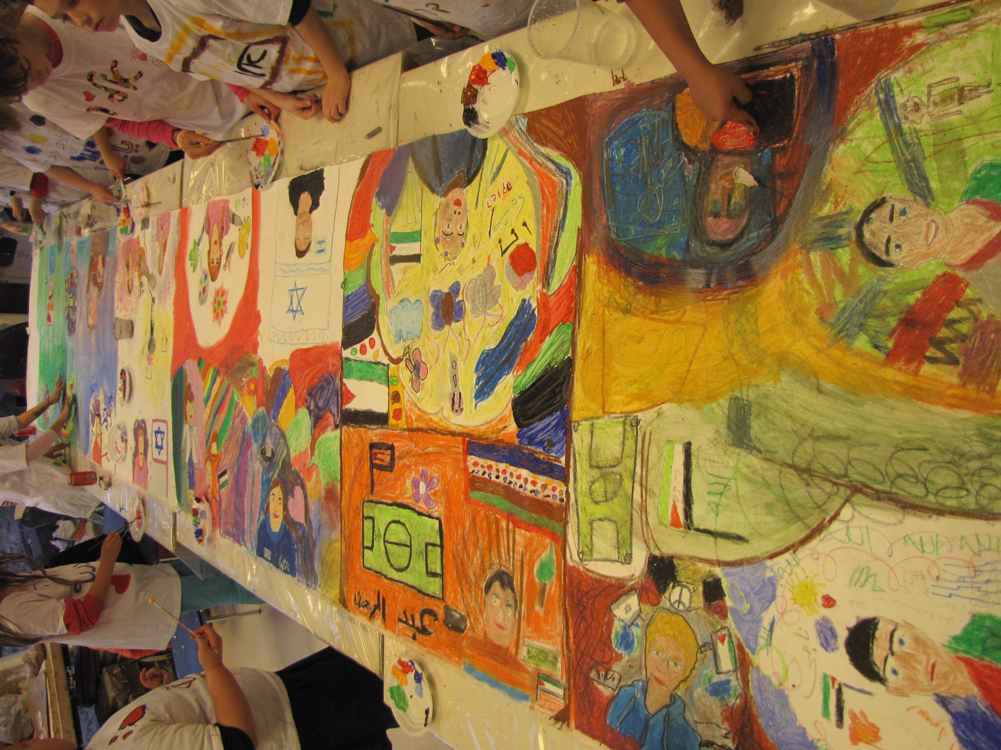
The Jewish and Arab students were divided up into mixed pairs so they could begin to learn to work together, and to foster dialogue and intimacy between them. Casting the masks encouraged students to get to know each other as individuals, and not merely as representatives of a certain group.
The next step was to create three-dimensional maquettes illustrating their hobbies. This activity further strengthened their commonalities, which were shown to be greater than their differences. As we have learnt through the years, once the students let go of stereotypical slogans and labels, they realize that they share similar pastimes such as: football, reading, theater, music, drawing, swimming, and horse-riding.
At the beginning of March 2013, Arab and Jewish sixth-grade children went on a visit to Jaffa that included seeing a play at the Arab-Hebrew Theater entitled “Two,” which dealt with the theme of cross-cultural friendship. Following the play, we walked to the Jaffa port where we created paper boats in small groups, in which we wrote our wishes, and set them free to sail in the sea.
After Passover, as each year, we discussed the Holocaust, Independence Day, and the Nakba. It became clear that there were many disagreements as well as a lack of accurate information on both sides. The presence of group instructors during the sessions helped maintain a therapeutic discourse and ultimately the meetings were of great significance, as both sides were made to listen to a narrative different from the one with which they were already familiar.
The end-of-year artistic project involved building a bus in mixed groups. A bus was chosen as it as a public place of meeting, where members of different communities, religions, colors, ages, and ethnicities mingle. It was wonderful to see how the children managed to work together in harmony. They helped each other, shared ideas and suggestions, and were totally immersed in the task at hand.

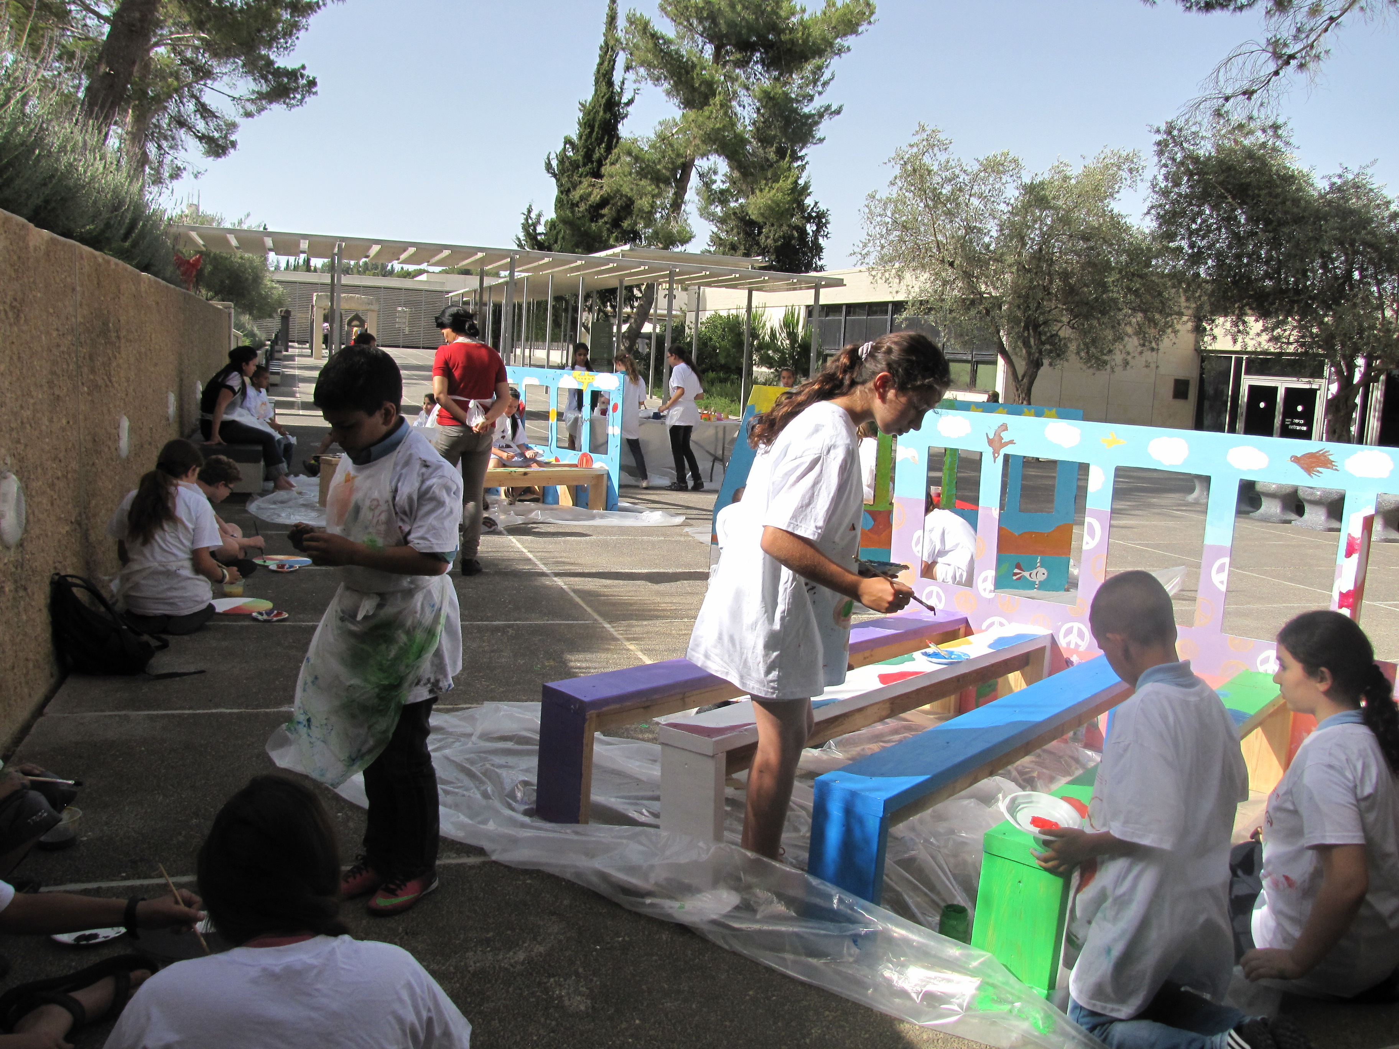

We realized once again that students can learn to cooperate despite their disagreements and despite being entrenched in their own narratives and beliefs. In our opinion, the program was a great success. Participants left the Museum with a better understanding of the “Other,” and especially how the other side feels. In the course of the year, the children learned that the issues are not 'black' or 'white', and that there is no such thing as 'good' or 'bad'. Instead, the story of the Arab-Jewish conflict is complex and nuanced, and is made up of many shades of grey.

Staff
The grade 6 group was taught by Arab artists/teachers Abu Baker Nasreen and Hannan Abu-Hussein, and by Jewish artists/teachers Yael Rubin and Ayala Landau. The translators were Elian Mountaser, Hasnin Ranya, Alian Safa, and Alian Dua. The group consisted of 22 Arab children and 18 Jewish children, a total participation of 40 students.
The grade 8 group was taught by Arab group instructor Siwar Masarwe and by Jewish artist/teacher Anat Bar'el, and by the Jewish group instructor Yael Rubin and the Arab artist/teacher Hannan Abu-Hussein. The translators were Nilly Ibrahim and Samiya Alian. The group consisted of 19 Arab students and 17 Jewish students, with a total participation of 36 students.
The entire program was led by Eldad Sha'altiel, Senior Curator of Art Courses at the Ruth Youth Wing for Art Education.

