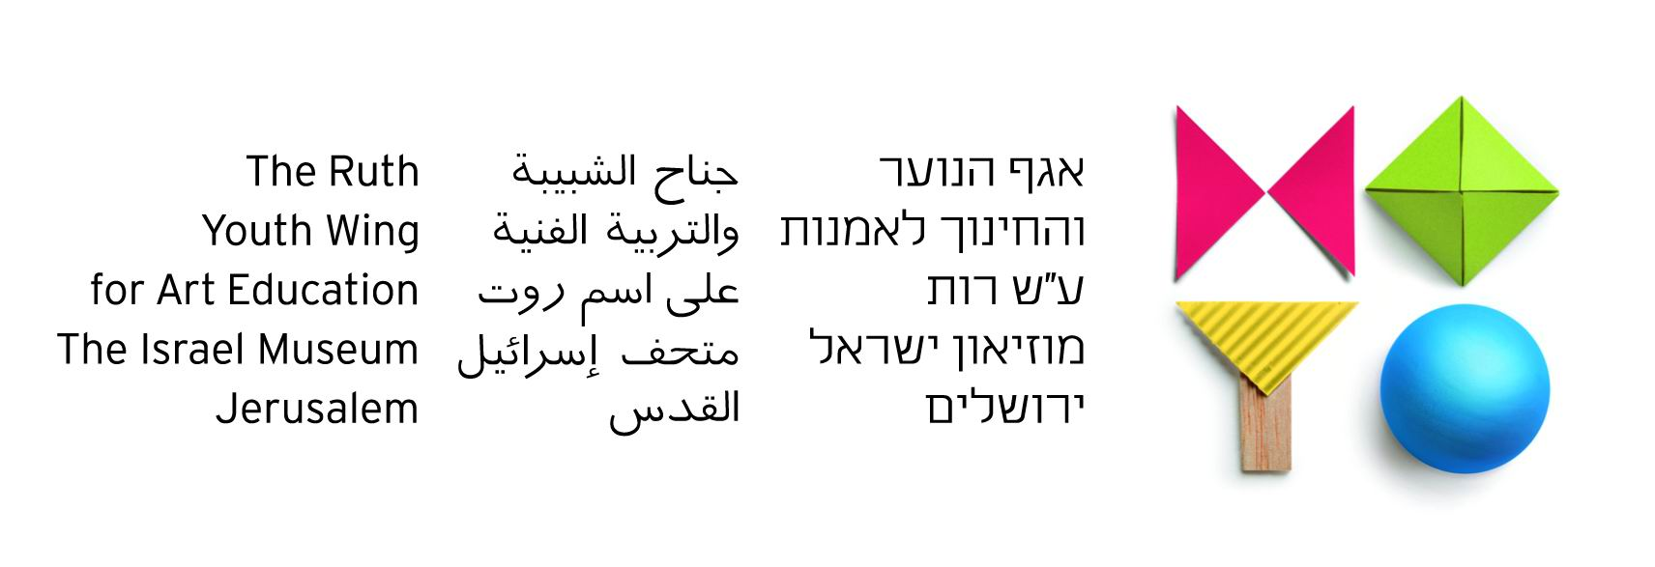

Bridging the Gap

The Jewish-Arab Art Program

2011/12 Report

The "Bridging the Gap" Art Program has been run by the Youth Wing for Art Education since 1995. In 2010, the German Friends of the Israel Museum became active and generous supporters of the program and through their generosity, it has become a great success both in terms of artistic quality, and in its ability to create opportunities for dialogue between Arab and Jewish youth in Israel.
Current Year Program
Introduction
During the 2011/2012 school year, seventy-six 6th and 8th grade schoolchildren from throughout Jerusalem took part in the program, divided into two groups. At the outset, in September and October 2011, we met with school principals, teachers, parents and administrators. Prior to September we had formed a select group of students based on two major criteria:
a) A demonstrated curiosity and commitment to dialogue with the 'Other'
b) An interest in and a motivation to create art.

Previous years have taught us that there can be a fundamental gap between Arab and Jewish students in their understanding of the ‘Other’. The Arabs did not regard the Jews as people of a certain nation, rather as a people of a certain religion that had come to take their land and country. In return, the Jews viewed the Arabs solely as Israeli citizens who live and coexist in Israel. Bridging the Gap staff decided to carefully address this issue in advance of the program and also throughout the year, by adapting certain aspects of the curriculum, and by anticipating obstacles before they appeared.
Program Curriculum
October-November 2011: ’Getting to Know You’ sessions including meetings with parents and introductory tours of the Museum galleries.
December 2011: Initial art exercises for individuals and pairs, guided tours of Museum exhibitions, and conversations about art to foster dialogue and exchange between participants.
January-February 2012: Exploring in pairs the concept of "Home" through art workshops in the classroom and in the Museum galleries.
March-April-May 2012: Developing the concept of "Home" by working in mixed groups, and planning the final project.
June 2012: A trip to Jaffa, preparing the final project "Our Shared House", and an end-of-year event with participants’ parents.
Program Narrative
This year’s program began in November 2011. The opening session was designed for children, parents and teachers together. We took them on guided-tours in the Museum galleries and then went into the classrooms for a collaborative art workshop.
The first couple of sessions dealt with making a puzzle out of the children's paintings. This taught the participants to work together, and conveyed the message that even though we are made up of different, individual 'pieces', when put together we create a whole unit. Moreover, only by combining our individual stories, will we be able to grasp the whole picture.
Later sessions included a series of creative projects such as making maquettes, casting masks, and creating imaginary rooms. The Jewish and Arab students were divided up into mixed pairs so they could begin to learn to work together, and to foster dialogue and intimacy between them. Casting the masks encouraged students to get to know each other as individuals, and not merely as representatives of a certain group.
Participants were then asked to create a room in which they would like to live. This activity further strengthened their commonalities, which were shown to be greater than their differences. Once the students let go of stereotypical slogans and labels, they realized they shared the same dreams regarding the concept of private space within their homes.
Stress was palatable among the group when missiles were launched at the southern city of Sderot, which was followed by IDF retaliation against Gaza. Both Arab and Jewish children were hurt and confused by the events of that period and accusations were made by both groups. Together, the two groups created some strong images depicting missiles, tears, and their fear of the war, sentiments felt strongly on both sides of the conflict.
After Passover, we discussed the Holocaust, Independence Day and the Nakba, which triggered harsh comments from all of the participants. It became clear that there were many disagreements as well as a lack of accurate information on both sides. Program staff realized that these issues were both sensitive and complicated, involving the demonization of the ‘Other’. The presence of group instructors during the sessions helped maintain a therapeutic discourse and ultimately the meetings were of great significance, as both sides were made to listen to a narrative different from the one with which they were already familiar.
Each mixed pair had to build one section of the house. It was amazing to see the children work together, in perfect harmony. They helped each other, shared ideas and suggestions, and were totally immersed in the task at hand.
At the beginning of June 2012, Arab and Jewish 6th grade children went on a visit to Jaffa that included seeing a play at the Arab-Hebrew Theater ("Journey to the Cheese Planet") followed by a walk at the Jaffa port and a painting session at sunset.
In the spirit of the program, students learned to cooperate despite their disagreements and despite being entrenched in their own narratives and beliefs. In our opinion, the program was a great success. Participants left the Museum with a better understanding of the ‘Other’, and especially how the other side feels. In the course of the year, the children learned that the issues are not 'black' or 'white', and that there is no such thing as 'good' or 'bad'. Instead, the story of the Arab-Jewish conflict is complex and nuanced, and is made up of many shades of grey.
Staff
The grade 6 group was taught by Arab artists/teachers Rawan Abu el-Hawa and Hannan Abu-Hussein, and by Jewish artists/teachers Orly Nir and Ayala Landau. The translators were Nilly Ibrahim and Samiya Alian. It consisted of 22 Arab children and 18 Jewish children, a total participation of 40 students.
The grade 8 group was taught by Arab group instructor Hannin Magedallah and by Jewish artist/teacher Anat Bar'el, and by the Jewish group instructor Ohad Hoffman and the Arab artist/teacher Hannan Abu-Hussein. The translators were Nilly Ibrahim and Samiya Alian. It consisted of 19 Arab students and 17 Jewish students, with a total participation of 36 students.
The entire program was led by Eldad Sha'altiel, Senior Curator of Art Courses at the Youth Wing.

