Bridging the Gap
Report 2018
General
For the past 24 years, the Ruth Youth Wing of the Israel Museum has been facilitating an enriching program for Jewish and Arab children called “Bridging the Gap.” The program facilitates art learning, art creation, and art collaboration for Jewish and Arab children. Over the years, “Bridging the Gap” has become one of the most important educational programs of the Israel Museum and experiences wide support from the participants, their teachers, and their community.
The children who participate in the “Bridging the Gap” program are 5th and 6th graders who come from diverse neighborhoods across Jerusalem and its surrounding areas; namely Silwan, Beit Safafa, Rehavia, Katamon, Baka, Kiryat Hayovel, and Beit Hakerem. The program is directed by both Jewish and Arab artist educators and each class takes place in both Hebrew and Arabic In addition, each class has its own bilingual translator. The participants meet every week for a year, so they have the opportunity to deepen their connections to each other and to the creative process. Each week, the participants arrive at the museum, eat a light meal upon arrival, and return to their homes by organized transportation.
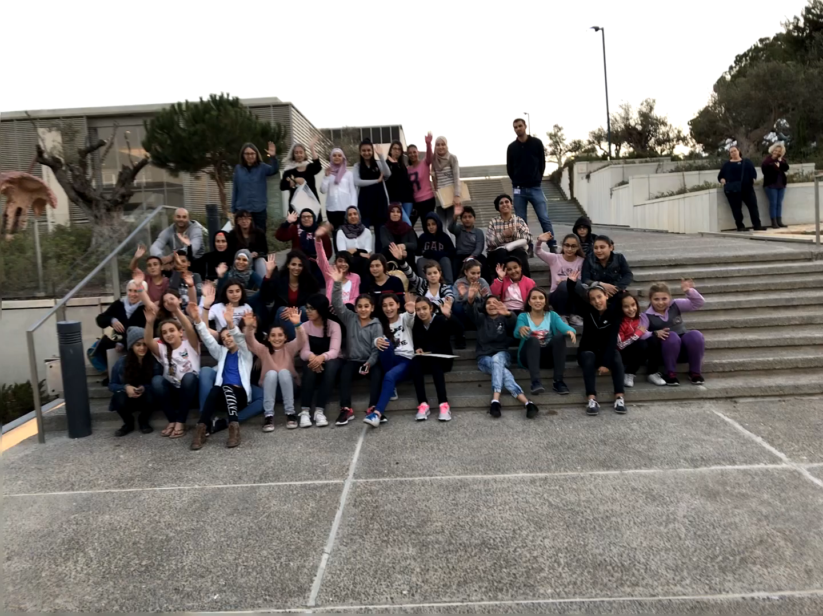
Data
In 2017 and 2018, 68 children participated in the "Bridging the Gap" program. The meetings were held on Wednesdays and Thursdays between 15:00 and 17:00.
On Wednesdays, 37 children participated in the program: 18 Jewish children from schools in the Kiryat Hayovel and Beit Hakerem neighborhoods and 19 Arab children from schools in the Silwan neighborhood.
On Thursdays, 31 students participated in the program: 13 Jewish children from schools in the Baka, Rehavia, and Katamon neighborhoods and 18 Arab children from the town of Beit Safafa.
This year, due to the fast of Ramadan, we had to terminate the program a few weeks earlier; however, we were successful in completing the content of the program nonetheless by making up this additional material throughout other weeks of the program.
Goals and their implementation
The program has multiple goals:
On a personal level, the program aims to encourage and facilitate personal interactions and connections between Jewish and Arab participants. This goal was achieved by working together in pairs and small groups, through social games and personal dialogue between the participants, and by experiencing a successful Arab and Israeli collaboration, at the visit to the Jaffa Arabic Hebrew Theatre on our field trip.
On a cultural level, the program aims to expand the horizons of the participants by exposing them to the museum and its exhibitions, such as the African masks collection, the pre-Columbian art collection, and the Jewish and Muslim art collections. The most prominent exhibition that inspired our 2018 programming was Jerusalem in Detail.
On a creative level, the program develops the children’s creativity and artistic abilities and thus, their appreciation for the creative process. Through personal expression in the language of visual arts and by learning and practicing in various art techniques, the children are exposed to a newfound world of imagination and possibilities.
The 2018 “Bridging the Gap” Process
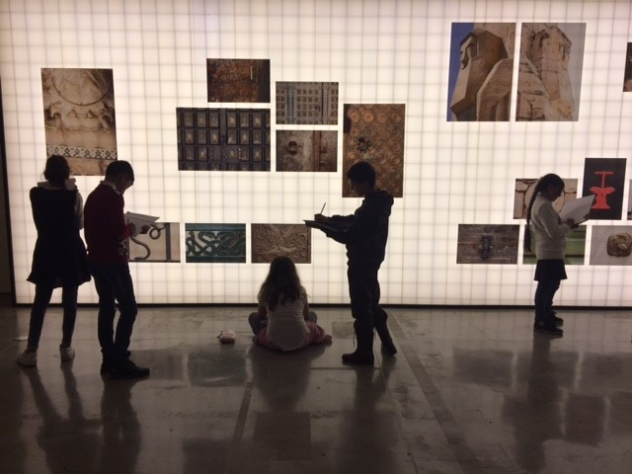
Jerusalem in Detail, the main exhibition for the 2018 winter season at the Museum, was chosen as the inspiration for the entire program this year. We found that the exhibition offers an opportunity to examine the commonality and differences of participants’ Jerusalem identity; thereby, deepening the understanding of the participants' mutual empathy for each other.
Student enrollment in the program differs between the Arab and Jewish sectors. In the Arab sector, enrollment in the program is based on academic excellence: students are chosen by their principals and not necessarily because of their love of art or their desire to meet Jewish children. In the Jewish sector, although the program is coordinated through principals, the students choose the program themselves rather than having the program chosen for them. In addition, in the Jewish sector, parental encouragement plays a significant role in the process. In the Arab sector, parents are more cautious and hesitant to send their children to The Israel Museum because of the unfamiliarity of the environment. What we have witnessed is the more exposure the Arab families have to the program, the more they become comfortable with it and committed to it.
The first meeting is held with the students and their parents from both sectors. During the initial meeting, we present the program, tour the exhibition halls of the museum, and draw together in the African Art gallery. The main goal of this meeting is to enable parents, especially Arab parents, to familiarize themselves with the museum, the staff and the nature of the activities; thereby, reducing the level of anxiety and concern for the children's safety. In past years, we have seen that parents become immediately comforted upon visiting the Museum and meeting the staff.
The next three sessions are devoted to introductory games and preparing a personal T- shirt with the name of each participant in both Hebrew and Arabic. This year, we prepared T-shirts with Palestinian-style embroidery, which was inspired by the Jerusalem in Detail exhibition of the Museum. The girls, who comprise the majority of the participants, are delighted to create their T-shirts using Palestinian embroidery techniques.
The Jerusalem in Detail exhibition was visited several times, each time with a focus on a different aspect or topic. The program was enriched by visits to the Museum's permanent exhibitions, mainly the Muslim prayer wall, MICHRAB, and the Jewish synagogues which the students explored in different lessons.
The Arabic script was used by the Muslims as a model for decorative ornament and was also influential in Jewish culture from Arab and European countries. Because both religions prohibit the use of human images, script was used as a decorative artistic expressive tool in both traditions.
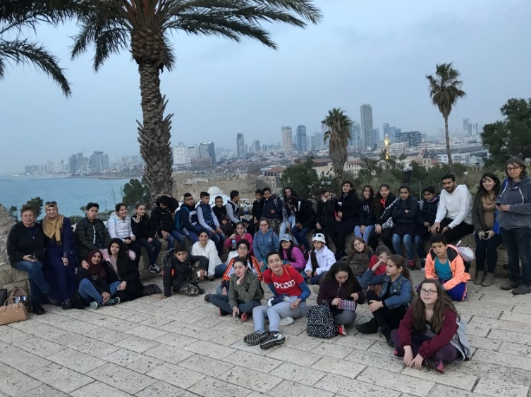
In February, the group went on an educational tour to the city of Jaffa. During the tour, they learned about the history of the city prior to 1948, events which occurred during 1948, and about the current Arab and Israeli relations in Jaffa. The children watched a theater play at the Arabic and Hebrew Theater called “Two,” which was performed by both Jewish and Arab actors who played in both languages ​​simultaneously. The play was a wonderful depiction of possible collaboration between Jews and Arabs.

At the end of the program, students were asked to create a final project in collaboration between Jewish and Arabic children. The final project consisted of mixed groups and required extensive cooperation. In this way, we encouraged strong collaboration and acquaintance between the participants. Each student created his / her own tile that was a part used in the group mural. While at the same table, both Arab and Jewish students worked individually on creating their own tiles. In the process of creation, they had informal and meaningful conversations about many topics. They seamlessly found common hobbies in their informal conversations, like when two boys discovered that they both love the same PlayStation games. Thus, personal relationships developed in these informal settings. Program participants created ceramic tiles that they painted in ceramic glazes and fired in the kiln. They then created a wall of painted tiles. The students glued the painted tiles on plywood slabs and gifted their creations to their respective schools.
We completed the school year with a festive gathering in the Museum, which comprised of the students, their parents, administrators from their schools, and museum staff. During the meeting, everyone participated in a short activity, which represented the program, and showed photographs from this year’s program (the presentation is attached). We completed the meeting with a joint meal, which was prepared by the participants and their mothers. During the last meeting, most of the parents and children thanked us for a successful program and requested for it to continue into the following year. We were happy to witness that most of the children who began the program completed it, marking its success.
Overall, we have had great achievements and a few challenges this year. We achieved most of our goals, despite the challenges.
Achievements
This program’s main achievement is its long lasting continuation, despite the variety of challenges that face the project every year anew.
In every meeting, we witness the immediate results of the way that the children connect to each other, form solid friendships, and are transformed through their interaction in this program. There are also intangible and unquantifiable results, which we can only identify by tracking success over time. In the field of education, results are oftentimes unveiled years after the participation in a certain program. We would like to field a longitudinal study to track the students over time in order to quantify the influence this program has on their upbringing.
Throughout the years, some students from this program continued to study in Bezalel and became artists themselves. This year two of them (Alaa and Abir) were so committed to the program that they returned as teachers. For these teachers, the program represents a home and a mission and they want to give back to the community which once gave to them.
Challenges and Coping Methods
I. Guidance and Support for the Teaching Staff
The teaching staff is comprised of both Jews and Arabs. Differences in political, social, cultural, and national worldviews, age, seniority, experience and pedagogical approaches mean that tensions may arise between staff members. The teachers’ challenges correlate strongly with the challenges that the students undergo and these inherent tensions must be addressed and mitigated, so that the relationships between the staff remain productive and positive since they serve as role models for the students. In order to strengthen the working relationships of teaching staff, we hired a psychologist and group facilitator to assist them to work through these differences and to create a space in which they can voice their feelings and opinions on painful topics. The therapists and group leaders also facilitated team-building activities.
The joint work made it possible to touch upon, and deal with difficult issues that lurked beneath the surface. Initially, teachers were reluctant to bring up these issues out of fear that they might negatively affect the team. Working with the facilitator enabled them to address these painful issues, deal with them in a constructive manner, and solve the difficulties that arose.
For instance, because the Jewish teachers were seniors and knew each other very well, they planned the classes curriculum without including the Arab teachers. Thus, the Arab teachers felt that they were pushed out, not making a contribution to the curriculum and were resentful. The Jewish teachers were unaware of this issue and when it was raised, it was immediately resolved by embracing the curriculum of the Arab teachers. Oftentimes, making both parties aware of the issue is all they need to implement a solution.
II. Commitment and Perseverance
There were cases where Jewish children left the program after a few meetings. In most of these cases, the departure was due to a discrepancy between the students' expectations and the nature of the activities in the program. In addition, Jewish children have a variety of after-school programs available to them, so they are less committed to one particular activity. Arab students, on the other hand, are less likely to leave the program since their principals treat the program as part of their academic curriculum.
We solved this issue by recruiting additional Jewish students from another school and inviting them to participate. The strategy was only partially successful because the late enrollment caused gaps between the new students and the existing students, which were very difficult to bridge.
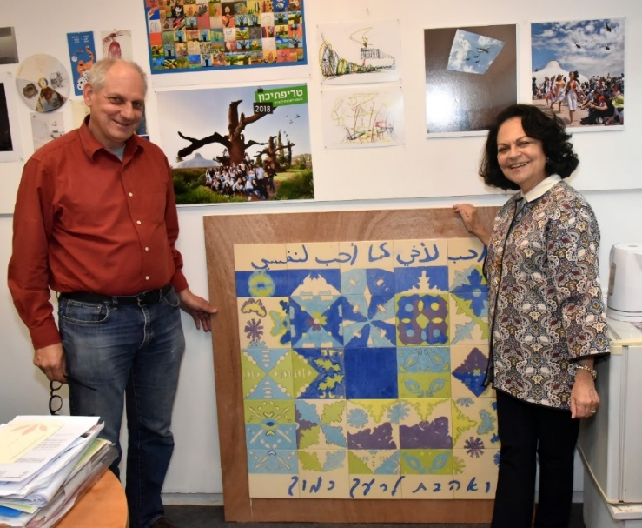
To mitigate these issues next year, we plan to recruit additional Jewish schools into our program. In addition, we plan to ask alumni of the program to present it to new students, so they are aware of the program details and their expectations are in alignment with them. We also plan to open enrollment earlier, so we can recruit students before they sign up for other activities. We hope that these steps will help us alleviate the dropout issue.
Staff
Wednesday's Team: Hiba El Kassem, Abir Najer, Roma Keinan and Yael Rubin
Thursday's Team: Alaa Idris, Abir Najer, Anat Barel and Yael Rubin
Translators: Rim Jabbara and Aya Osman

